# CS 255 System Design Document Template

This template lays out all the different sections that you need to complete for Project Two. Each section has guidance to prompt your thinking. You will need to continually reference the interview transcript as you work to make sure that you are addressing your client’s needs. There is no required length for the final document. Instead the goal is to complete each section based on what your client’s needs are. Remove this note when you are finished, and replace all bracketed text with the relevant information.

## UML Diagrams

### UML Use Case Diagram

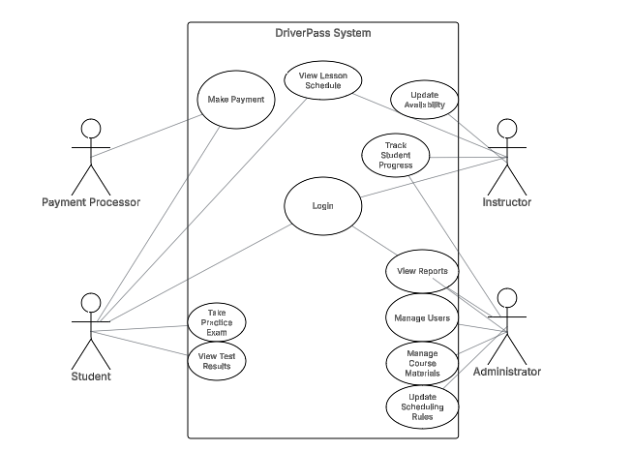

### UML Activity Diagrams

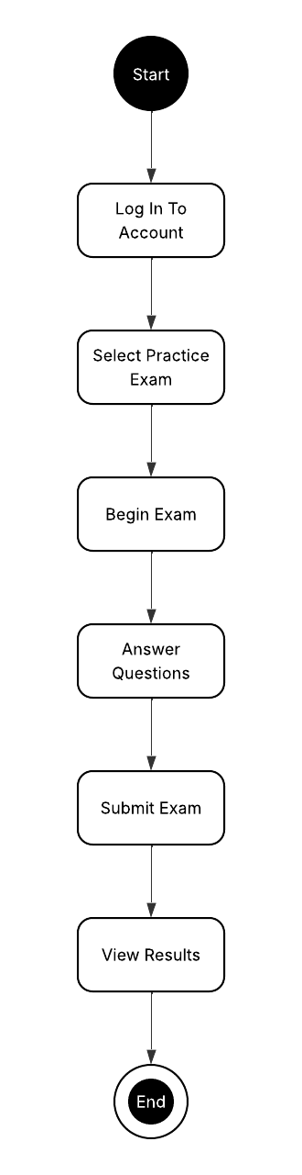

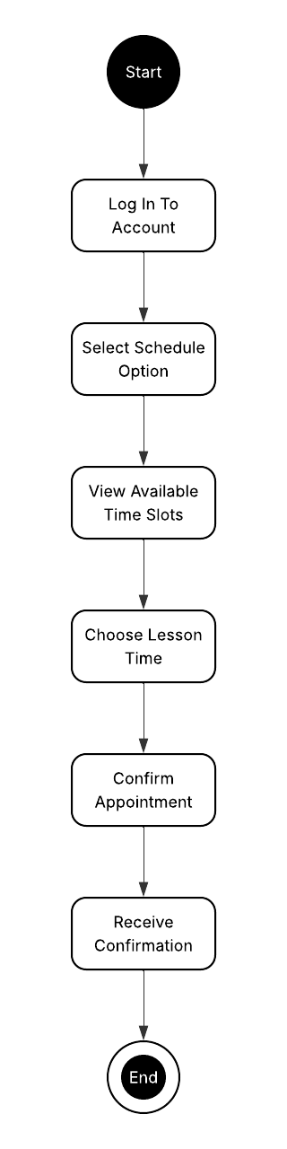

### UML Sequence Diagram

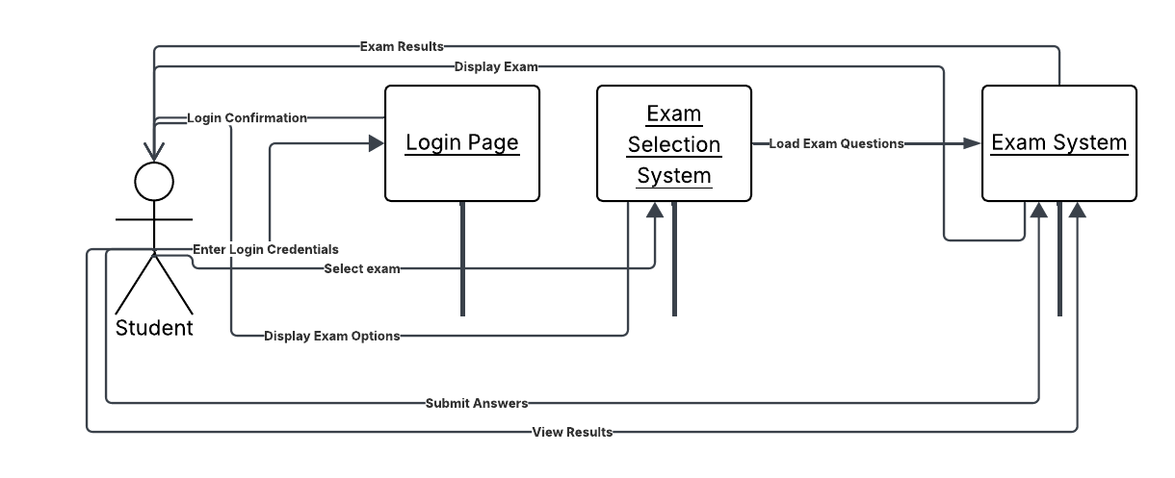

### UML Class Diagram

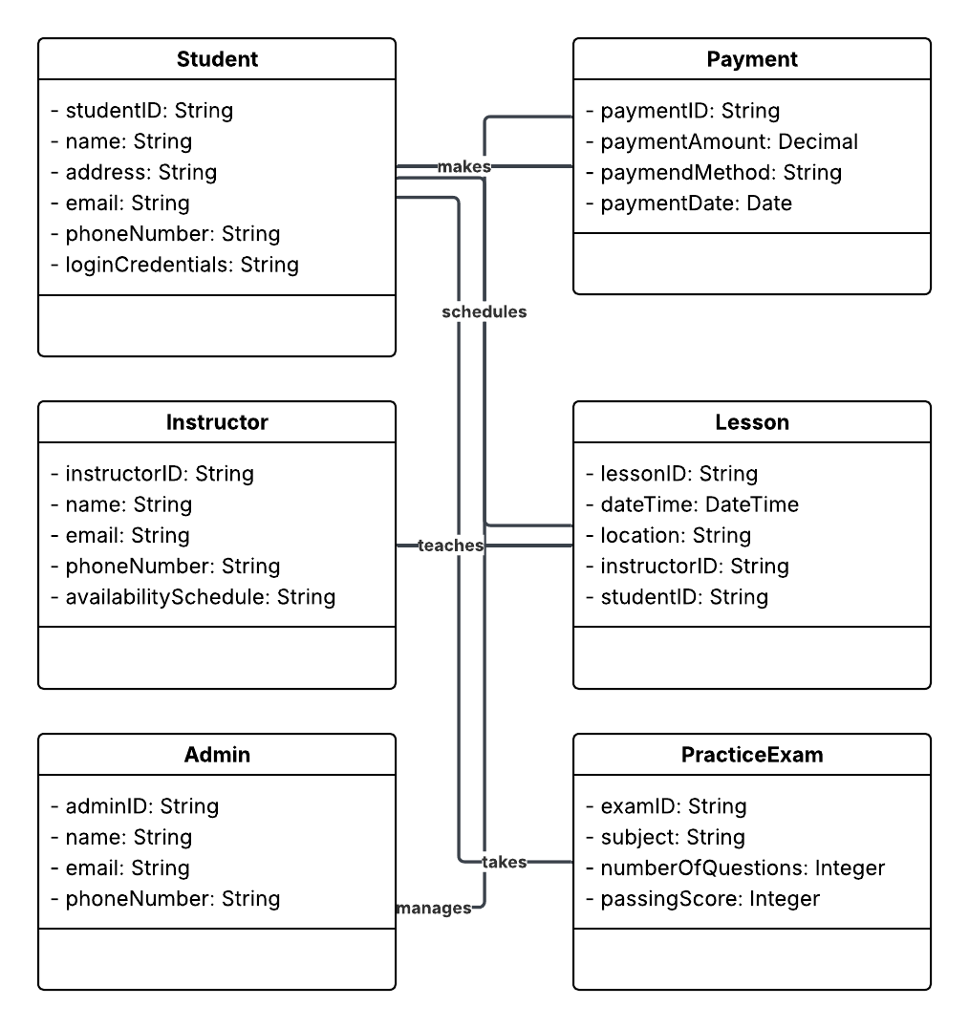

## Technical Requirements

The following technical requirements have been identified to ensure the DriverPass system operates securely, efficiently, and reliably for all users.

Hardware Requirements:

* Cloud-hosted servers capable of handling web traffic and data storage.
* Secure database servers to store user information, scheduling data, and exam records.
* Reliable backup systems for disaster recovery and data redundancy.
* Student and staff access via laptops, desktops, tablets, and smartphones.

Software Requirements:

* Web server software to host the DiverPass platform.
* Application software developed using a modern web framework.
* Database management system to manage and store structured data.
* Secure payment gateway integration for processing transactions.

Tools Required:

* CASE tools such as Lucidchart for ongoing system modeling and updates.
* Project management and collaboration tools.
* Code repositories and version control using Git and GitHub
* Monitoring tools to track server uptime, application health, and potential security threats.

Infrastructure Requirements:

* Cloud hosting service (such as AWS, Azure, or Google Cloud) for scalability and reliability.
* SSL/TLS encryption certificates to secure all data transfers between users and the server.
* User authentication and authorization systems to support different user roles (Student, Instructor, Admin).
* Regular system backups scheduled daily with incremental updates throughout the day